Social Interaction and Cooperative Activities:
Drawing Plans as a Means of Increasing Engagement for Children with ASD

Brenda Peters, Chris Forlin, Dennis McInerney and Rupert Maclean
Hong Kong Institute of Education

Abstract

A substantial amount of learning in schools takes place within social contexts and class-based group activities; however, social learning situations, communication and social cognition development for children with ASD can be a challenge for the children and their teachers. This paper explores what happens when children with ASD draw activity-plans about cooperation and play, and how ideas about collaboration with peers can be introduced and developed. Initial qualitative data from video and the children’s hand drawn pictures reveal their prior experiences of working with others, however, through drawing plans about engaging in intentional social communication and cooperation activities, the children change their ideas about working together. This study finds that children’s illustrations portray their concepts of play with others, communication, conflict, and humour, as well as eventually the inclusion of others in constructive activities.

Keywords: Autism, self-regulation, problem-solving, communication, social-cognition development, activity-plans

Children with ASD in Regular Schools

The inclusion of children with special educational needs into regular schools has resulted in teaching becoming more complex (Florian, 2009). Humphrey (2008), and Jorgensen and Lambert (2012), stated that teachers often encounter challenges in engaging children with ASD within regular classrooms. Moreover, class difficulties seem to stem from the children’s social communication and interaction challenges in social learning activities. One of the biggest learning challenges for children with ASD is learning by socio-cultural means (Jordan, 2008), and, as stated by McInerney (2010) concerning children within regular schools, curricular learning activities are often socially based. Meaningful educational experiences, therefore, should consider each learner’s potential to achieve within social and cultural contexts (McInerney, 2010). Furthermore, school communities that include all stakeholders in every aspect of school life should be encouraged (McGregor & Forlin, 2005), including children with ASD attending regular schools and their families. These principles align with the eight principles approach to whole schooling as advocated by the Whole Schooling Consortium (e.g., Peterson, 2007).
Kanner (1943) first wrote about the difficulties of Children with ASD, and highlighted their inability to relate to others from birth. Updates to the criteria for Autism Spectrum disorder, according to The Diagnostic and Statistical Manual of Mental disorders fifth edition (http://www.dsm5.org/Pages/Default.aspx), states that “People with ASD tend to have communication deficits, such as responding inappropriately in conversations, misreading nonverbal interactions, or having difficulty building friendships appropriate to their age” (p.1). ASD is recognised as a neuro-developmental disorder (Newschaffer, Croen and Daniels et al., 2007).
Social constructivism in learning has been a starting point for a number of interventions in regular education such as self-regulation, peer tutoring, and scaffolding (McInerney, 2005). More recent research has focused on student motivation through inquiry-based and collaborative learning, high teacher expectation, and supportive pedagogy (McInerney, 2005; Jarvela, Volet & Jarvenoja, 2010). There is a dearth of literature that concerns socially based learning, engagement activities for children with ASD and regular schools.
Incidences of social cognitive development strategies in pedagogy and the employment of cooperative learning strategies for inclusion may already occur in classrooms (Johnson, Johnson & Smith, 1998), however, advances found from social cognitive aspects of learning, as indicated by McInerney (2005) and Jarvela, Volet and Jarvenoja (2010), might also enable children with ASD to be successful learning community members in regular classrooms. These aspects of learning have yet to be fully recognised in everyday class practice in regular schools in the Asia Pacific region (Peters & Forlin, 2010). Furthermore, there is a dearth of literature from the region relating to children with ASD in regular schools (Peters & Forlin, 2010), and their participation with peers. In an attempt to bridge this gap, the research presented in this article reports a section of results from the author’s study that investigated social communication and interaction for children with ASD in Hong Kong and a model to enhance social communication and interaction, the SCI model was developed.

Social communication

Extant strategies used by teachers in regular schools with children with ASD to improve social interaction, have originated from strategies developed within specialist provision (Jordan, 2008). A review of literature from 2003-2007, conducted by Parsons, Guldberg, MacLeod, Jones, Prunty, & Balfe (2009) on evidence-base practices and children with ASD, found behavioural therapy-based strategies and the acquisition of functional skills for inclusion, focused on language acquisition, adaptive behaviour, and social development models. Moreover, Parsons et al. (2009) found paucity in the quality of research studies for children with ASD, too few meeting the ‘high weight of evidence’ criteria identified by the Evidence for Policy and Practice Information and Coordinating Centre (Sheehy, Rix, Collins, Hall, Nind & Wearmouth 2009). Parsons et al. (2009) exposed a number of methodological issues with research concerned with common communication-based treatments for children with ASD, most importantly that the majority of studies had a single subject design, lacked randomized controlled trials and often had no follow-up at the end of the treatment period.
Brunner and Seung’s (2009) extensive literature review of communication treatments for children with ASD examined specific interventions, for example, Applied Behavioural Analysis (ABA) (Lovaas, 1987), Treatment and Education of Autistic and Related Communication-Handicapped Children (Van Bourgondien, Reichle, & Schopler, 2003), and Project DATA (Developmentally Appropriate Treatment for Autism (Schwartz, Sandall, McBride, & Boulware, 2004). Evidence presented from studies on ABA examined over a period of five years, found that children who had a history of symptom regression did better in the ABA programme, however, it was further suggested that children with a history of regressive symptoms might have “made even larger gains with another more naturalistic or developmental treatment method” (Brunner & Seung, 2009, p. 17).

Social cognition

Effective learning behaviour is a result of social-cognition and meta-cognition development (Goswami, 2008). Social cognition enables individuals to predict behaviour and the emotional states of others (Goswami, 2008). Meta-cognition is enabled through the ability to plan and reflect, which is linked to the development of executive function and improved reasoning (Goswami, 2008; Frederickson & Cline, 2009). As such, greater achievement and school success may follow.
In getting to this level of cognitive development, research conducted with pre-school aged children has examined “effortful control”, which requires acting according the rules, for example, playing “Simon says” or responding to a signal (Shonkoff & Phillips, 2000). In order to play these types of games successfully, children need to be able to pay attention and play according to the rules of the game, which may mean stopping what they are doing when “Simon says” or when they see a red light for example.
Children about the age of five enjoy playing different play roles with peers and are able to negotiate conflict. Successful play at this age is dependent on peer interaction throughout the pre-school years. Children who lacked these types of early interactions have been found to increase the frequency of interactions with peers when in adult supervised play. In addition, Shonkoff and Phillips (2000) determined that “deliberately creating opportunities for peer interactions, encouraging keen observation skills and coaching young children in constructive attitudes and skills” (p. 180) was equally important.
Social aspects of cognition development for children with ASD have included various social skills intervention programmes such as Social Stories. Positive outcomes associated with this intervention include child ownership and self-reading of their social stories (Sansosti, Powell-Smith, & Kincaid, 2004). Evidence-based research to warrant the use of social stories within the school environment is, nevertheless, lacking according to Bellini, Peters, Benner and Hopf (2007).
A relatively new strategy initiated by Le Goff (2004) for children with ASD, harnessed students natural interests in LEGO®. The programme was designed to engage children with ASD in structured play activities that combined aspects of behavioural therapy with natural communication. In Le Goff’s program, LEGO® was purported a therapeutic medium. Groups of three children with ASD played with the materials for an hour per week for 24 weeks within a therapeutic context. The programme incorporated rules and assigning the children roles, such as builder, planner and supplier. Le Goff (2004) found the children’s motivation to socially engage with peers increased and additional outcomes included a developing ability to sustain interactions, a reduction in classical social behaviours of inflexibility, and a reduction in aloofness often associated with the characteristics of ASD. The longitudinal effects of the study on the students were reported in a subsequent study (Le Goff & Sherman, 2006). A third research study compared LEGO © therapy with another social language programme to examine incidences of self-initiated communication within a therapy context. This research found that social communication skills of the LEGO© group were better than the non-LEGO© group (Owens, Granader, Humphrey, & Baron-Cohen, 2008).

Planning for social interaction

Programmes such as Tools of the mind (Bodrova & Leong, 2007) have incorporated children’s drawings in planning for play followed by quality play, which have been found to promote social communication amongst pre-school aged children (3- 5years) from deprived backgrounds in regular school provision. In a randomised control trial of the Tools programme, pre-school children’s executive function skills and classroom quality were found to improve when planning and drawing pictures about play activity were involved. Incidences of children’s behavioural difficulties decreased as their self-regulation language was promoted through drawing and talking about activity-plans (Barnett, Jung, Yarosz, Thomas, Hornbeck et. al., 2008). Stubbs (1995) showed that children’s drawings may contain essential and/or hidden information, and visual representation has been used in the assessment and evaluation of learning (Bustle, 2004). More recently Eldén (2013) stated that “engaging with images is often part of children’s everyday lives, and is experienced as ‘fun’, ‘relaxing’, ‘triggering remembering’, ‘helping the abstract become concrete’, ‘minimizing the power relationship between the adult researcher and child” (p. 68).
Educational interventions to support early participation and cooperation for young children with ASD should include “a range of stimulating hands on activities and a variety of visual inputs with appropriate problem–solving opportunities” (Peters & Forlin, 2011, p.139).
There is, nonetheless, a dearth of literature related to the use of visual imagery and children with ASD for planning, expression, understanding, and reflection on social interaction and cooperative activity. In an attempt to bridge this gap, the author developed a social communication and interaction model (SCI) for use with children who experience social communication and interaction difficulties, such as children with ASD.
The SCI model. The SCI model combined drawing activity-plans (e.g., planning for participation in activity, as in the Tools of the mind programme (Bodrova & Leong, 2007)), and role-play for children with ASD, as in the LEGO© therapy programme (Le Goff, 2004). Furthermore, mediation through the use of tools was a fundamental concept of the SCI model. The model comprised three elements that aimed to enhance the children’s participation. These were roles, rules and tools. In addition, activities were adapted to incorporate the three elements.
Roles. There were three roles. The children knew which role they would play because the role badges had a picture alongside the title planner, supplier or builder. The planner read the plans, explained what materials were needed and told the others what to do; the supplier found the materials and gave them to the builder who had to listen to the planner and construct the model.
Rules. The rules were printed and consisted; build together, fix things when you break them, play your role, be polite, and, tidy up at the end of a session, and were similar to the rules in Le Goff’ s (2004) study.
Tools. The traffic light cards were developed to help the children stop play and figure out how to get play back on track. The cards were circular and coloured red, orange and green. The cards read “Problem”, “What’s the problem?” and “Strategy” respectively.
Activity. The researcher has a bank of activities that could be adapted to incorporate the rules, traffic light cards and the roles. Activities for included making a LEGO ® model, following a recipe, making puppets or other three dimensional models, or playing a game.

Method

Participants

Before the study commenced, ethical clearance was received through the researcher’s institution. The method for obtaining the sample of children is reported in detail by Peters, Forlin, McInerney and Maclean (under review), however, for the purposes of this article, Special Educational Needs Co-ordinators (SENCO) in three primary schools identified children with social communication and interaction difficulties. The study’s participants, therefore, consisted 12 children with a diagnosis of ASD with no reported regressive symptoms. All the children could read.
A letter was sent to parents by the school asking permission for the children’s involvement in the study and for the researcher to access school records. Once permission was received, the identities of the children were revealed and details of the children’s assessments and diagnoses were provided. Table 1 shows the children’s information supplied by each school.

Table 1
The reported age, diagnosis and IQ scores of the children(WISC).
 | Age | IQ
 |  | Diagnosis | Verbal | Performance | Overall
Cameron  Casey  Charlie | 5.0  6.0  6.7 | Mild ASD  Mild ASD  AS | No report  No report  No report | No report  No report  No report | No report  No report  No report
Dakota  Devyn  Dylan  Jessie  Jamie  Jordan | 6.1  5.9  5.1  7.0  6.1  6.2 | AS (PDD)  Mild ASD  AS  AS  Mild ASD  Mild ASD | 105  80  90  No report  106  72 | 175  112  121  No report  77  10 | 94  92  104  No report  94  Not computed
Ali  Avery  Alexis | 6.0  5.9  5.0 | AS  Mild ASD  Mild AS with AD/HD | 81  101  91 | 82  103  105 | 79  101  104
Note. Autism Spectrum Disorder (ASD), Attention deficit/ hyperactivity disorder (AD/HD), Asperger’s Syndrome (AS), Pervasive Developmental Disorder – Not Otherwise Specified (PDD NOS)

The majority of children attending each school were of Chinese ethnicity. All three schools were co-educational schools with English as the medium of instruction, and approximately 90 to 120 children enrolled per year. Each school followed the Primary Years Programme (International Baccalaureate http://www.ibo.org/pyp/). According to parent interviews, entry into the schools is competitive. All the children involved in the study had previously attended international kindergartens, where there had been a focus on English and academic skills.

Procedure

There were four activity groups that consisted three children. The children knew each other, as some were in the same class and others had contact with each other in small group withdrawal sessions.
The children were asked to draw a picture of themselves with friends playing a favourite game and /or activity. They were provided with paper, coloured pens and pencils, and allowed five minutes to draw. The children were then asked to make something together with the materials provided, which comprised a basic LEGO ® building kit of bricks, LEGO ® people, and accessories such as trees, flowers and car wheels. Sufficient resources were provided and each pre-experimental activity session lasted up to 40 minutes. The activity sessions took place in classrooms familiar to the children.
Data. Baseline data consisted the children’s activity-plans and video footage of each pre-experimental activity session. In addition, video of the children in class and during playtimes was taken. Further, parents were interviewed in order to gather information about the child’s social communication and interaction in the home environment. Furthermore, parents were asked to send email updates about home activities, social encounters and when the children talked to them about school.
It was expected that activity-plans and video footage would provide a baseline of the children’s collaboration, social communication and interaction. These data were collected throughout the experimental activity period.
Data analysis. A themed perspective was adopted for data analysis and reported in detail by Peters, Forlin, McInerney and Maclean (under review). The children’s initial activity-plans were scrutinised for representations of social activity with others. For example, the numbers of figures present, evidence of any interaction between the figures including figure orientation, emotional display such as smiling faces and activity (e.g., play with a toy, child or adult). Subsequent activity-plans were coded for representations of social activity and interaction in addition to the aforementioned features.
Video footage was analysed for evidence of the children’s participation by two observers, who systematically recorded when the children initiated interaction with peers, when the children imitated peer language and actions. In addition, any dialogue that occurred between group participants was transcribed. Parent interviews were also transcribed and analysed using a thematic approach. All themes that emerged from data were discussed and verified with the other authors.

Experimental activity sessions

Care was taken to ensure that the children continued to meet curriculum entitlements during the experimental activity period. For 10 weeks all activity sessions were conducted in a withdrawal classroom familiar to the children within the school. Each session lasted up to 60 minutes.
Structure of the Sessions. The sessions followed a set procedure: first the children drew an activity-plan, then the children’s plans and rules were placed within view. The Traffic Light (TL) cards were also placed within easy reach. At the start of the experimental activity programme the adult identified potential communication problems as they occurred and showed the children how to use the cards. As the children became more practiced and competent at recognizing communication breakdown, they used the cards independently.

Results

The results of the pre-experimental activity sessions are presented under the heading Time 1. Data gathered at the end of experimental activity period are presented under Time 2.

Time 1
The children’s individual concepts of cooperation were explored before the Social Communication and Interaction (SCI) model was implemented. These activity-plans are shown in the following section.
Activity-plans. At the start of the pre-experimental activity session the children were asked to draw a picture of their favourite activity they liked to play with friends. Dakota provided a picture based upon a class story she had heard earlier in the day, as shown in Figure 1.

Figure 1. Playing a favourite game with friends by Dakota.

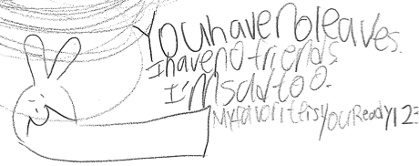

In interview Dakota’s mother was concerned about the words written on the picture, however, Dakota’s class teacher confirmed the words referred to a story she had read to the whole class that afternoon. It can be seen from Dakota’s drawing that she used remembered words in her illustration to meet the researchers’ request.

Figure 2. Playing a favourite game with friends by Dylan.

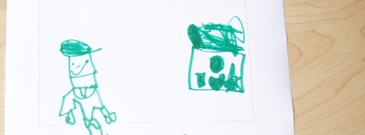

This picture depicts Dylan’s initial idea about play with a friend.
The other children in the groups provided different ideas of play with a friend. Figure 2 showed Jordan’s ideas.

Figure 3. Playing a favourite game with friends by Jordan.

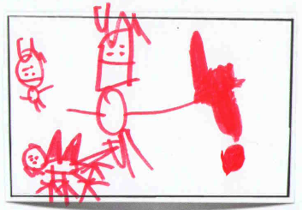

Jordan’s plan showed his favourite game of playing dinosaurs, which his father corroborated during interview. Figure 3 shows that Jordan understood another child was to be included in play, as he drew them in the activity plan. The idea of cooperation and playing with peers, however, was not shown. While Jordan understood the instructions were to draw playing with a friend, the other child in the picture was drawn much smaller. Moreover, the dinosaur was placed in closer proximity to Jordan than the friend. (The red block of colour covered a mistake he had made).
Alexis’ activity-plan, shown in Figure 3, indicated she was going to build a house. The picture only showed Alexis, however, she had also drawn three hearts, which meant she would enjoy the play. She included a tree and garden, which connected to the class topic of inquiry. The absence of peers in this picture was unexpected as her mother reported Alexis had regular play-dates. From the video footage she seemed to be socially aware of the other children in the group during the initial session.

Figure 4. Playing a favourite game with friends by Alexis

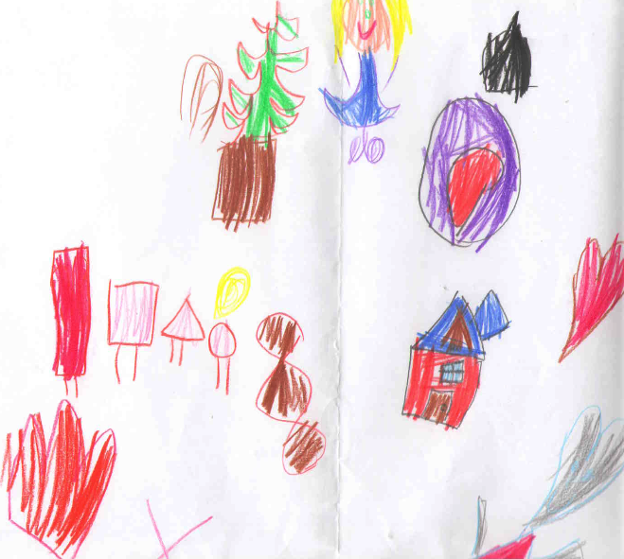

A further illustration of play with others was shown in Cameron’s activity-plan in Figure 4.

Figure 5. Playing a favourite game with friends by Cameron.

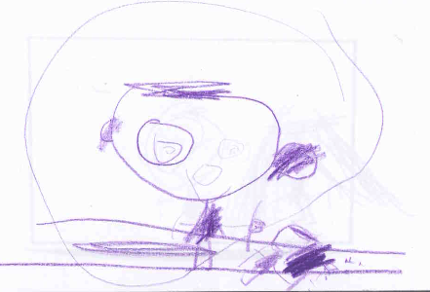

As indicated in Figure 5, Cameron’s idea of play with others was play with his little sister. It did not show them playing together or cooperating. Instead, he positioned the smaller figure on the floor either sleeping or hurt. Parent interview confirmed the sister was about three years younger and was possibly why she was drawn much smaller. His parents’ reported Cameron was protective of his toys when the younger sister wanted to play, and this provided a possible explanation of why the smaller figure was drawn lying down and Cameron was drawn encased in a circle.
Alexis, Avery and Ali decided that after drawing their own pictures, they wanted to draw one together (see Figure 6). The activity plan shows them playing together and being happy.

Figure 6. The first collective activity-plan provided by Alexis, Ali and Avery.

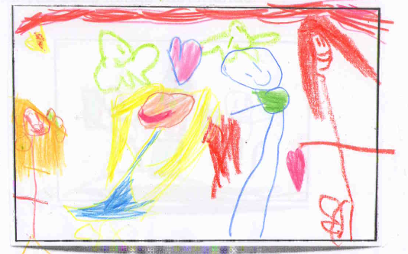

The picture shows the children had an awareness of each other and a concept of collaboration, for example, feelings of collegiality were indicated by the presence of many hearts and every figure in the activity-plan is smiling. The children also drew themselves in close proximity, however, the characters have been drawn facing away from each other.
Speaking with others. Video data indicated Dakota was the only child who did not interact with the adult or the other children, as she preferred to write by herself. Furthermore the frequency of interactions between Time 1 and 2 were recorded for each group and, for the purposes of this article, are provided in the appendices (see Appendix A).
Pockets of interaction and initiation occurred at Time 1, and the following dialogue between Avery, Alexis and Ali is provided as an example:

Avery: I have LEGO at home, [looks to adult]
Alexis: Me too. [Looks to adult]
Avery: Can we make some tractors? [Looks to adult]
Avery: We’re going to make the biggest farm ever. [Toward the other two children]
Alexis: I’m going to make the biggest tower ever. [No eye contact]
Ali: And I’m going to make the coolest, coolest car ever. [No eye contact]
Avery: Look a rabbit in the park. [Looks to adult]
Adult: I’ve found a tree.
Avery and Alexis: I want a tree. [Looks to adult]
Adult: Oh Look! [All children look] I’ve found another tree!
Alexis: [Takes tree from adult] Do you want a tree Ali? [Looks towards Ali and offers the tree].

In this sample of dialogue one of the children attempted to initiate conversation with the others, however, the process was gradual. As well as initiating social communication, the sample shows the children’s use of verbal imitation, for example, building the biggest. In addition, when the children wanted something they might grab the object or block others from seeing it. Alexis for example wanted to have everything that Ali had and used emotive language such as “ I’ll be your best friend” and then grabbed the object in question.
Video data for all four groups indicated few incidences of collaboration, cooperative building or toy sharing.
Dakota, Devyn and Dylan’s group was the most challenged by social interaction with each other. They did not dialogue in the pre-experimental activity session (see Appendix A). The following sample of dialogue for this group, therefore, is taken from session four:

Devyn: I can build it my own. We have makes... [Exerts himself by blocking the others from playing with track].
Adult: There’s a problem what shall we do? [Track doesn’t fit and adult models the traffic light cards]
Devyn: We still have more. It didn’t fit! We have to put the piece like this so it works.
Adult: Can I make a suggestion? (shows green card) Can we take this piece out and then it will fit?
Devyn: But it cannot- Give me it all [uses sensori-motor problem-solving strategies and snatches pieces from Dylan].
Adult: Maybe you can ask Dylan [Devyn ignores suggestion and continues taking Dylan’s track. He uses sensori-motor problem-solving and grabs the track. Shouts].
Devyn: Give me a switch track- give me all the straight tracks, please. Look, it wouldn’t fit [Avoids eye contact with others and positions body to exclude others from accessing the taken piece. He demonstrates sensori-motor problem-solving strategies. Dylan retrieves the piece].
Devyn: Hey give it back!
Dylan: It’s mine!
Devyn: No!
Dylan: My turn.
Devyn: Mine - I still want to fix this.
Adult: Problem! Let’s put the blue track away... [They had finished playing with the blue track and were arguing about the black track]
Devyn: No.
Adult: ...because you’re not playing with it any more, are you Devyn?
Devyn: I want to play with this [Takes blue track, uses sensori-motor problem-solving strategies and grabs the track].
Adult: You and Dylan can play with this, can’t you?
Devyn: No.

The extract indicates that Devyn was focused on getting the track. He used sensori-motor problem-solving strategies to block the others from taking the materials. Furthermore he vocalized loudly in response to the situation and his perception of the problem. Devyn’s approach possibly indicated needs fulfilment. These types of reactions may indicate immaturity, an inability for self-regulation, a lack of problem-solving and a lack of social emotional awareness. Devyn’s actions, however, may also be interpreted as the beginning of self-monitoring development.

Time 2
This section reports the findings from the children participation in 10 sessions of experimental activity. It reviews activity-plans collected at Time 2 and samples of dialogue from the last sessions for each group.
Activity-plans. Dylan’s idea of cooperation with another is shown by Figure 7.

Figure 7. An example of an activity-plan provided by Dylan.

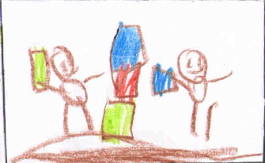

Dylan drew building a tower with a classroom peer and, as can be seen in the plan, he drew the figures the same size. Dylan depicted himself holding the blue brick and according to the colour sequence of the bricks, his friend was going to take the next turn. Dylan’s mother reported he was an only child and had few positive interactions with peers at school. This activity-plan, therefore, may indicate Dylan’s readiness for collaborative activity and co-operation in play.
Jamie and Jessie attended the same school as Dylan, and provided the following activity-plans. Jamie’s plan also indicated his participation with peers in the classroom.

Figure 8. Working with three friends in a class activity, provided by Jamie.

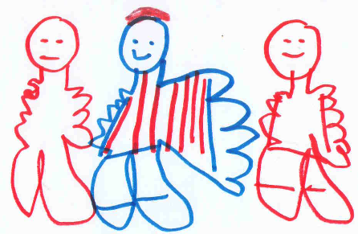

In Figure 8, Jamie depicted himself and his peers as smiling and happy. Jamie drew all the characters the same size, although he differentiated himself from the others by the blue outline and striped clothes. Jamie placed himself at the centre of the plan and indicated his helpfulness by the size of his left hand. In the activity sessions, Jamie liked to take the roles of the builder and supplier. Classroom observations recorded at Time 2 showed Jamie working with two peers at a computer task. One of the peers in Jamie’s group operated the computer and Jamie and the other peer observed and gave suggestions. Jamie did not attempt to dominate the computer.
Jessie chose to draw himself in the playground playing basketball with another child, as in Figure 9.

Figure 9. Jessie’s drawing of cooperative games with a peer in the playground.

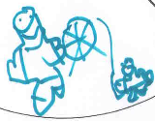
Video footage of playground activity corroborated Jessie’s activity-plan as at Time 2, Jessie played basketball with Jamie and a class peer for the duration of playtime.
The activity-plan shown in Figure 10 was produced by Alexis, Avery and Ali.

Figure 10. An activity-plan provided by Alexis Avery and Ali.

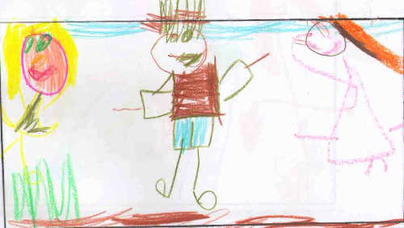

As indicated in Figure 9, the characters are smiling and Ali drew herself half turned towards Avery, seemingly ready for social interaction. An additional illustration provided by this group indicated their understanding of conflict within the group (see Figure 11).

Figure 11. An example of the Ali, Avery and Alexis’ collective understanding of conflict.

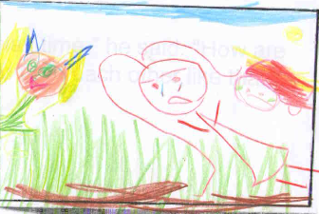

As shown in Figure 11, Ali and Avery have sad faces and Alexis caused the upset. Video data and field notes indicated there were issues of conflict between the children during the early experimental activity sessions. Alexis liked to be in charge, however, she was also easily distracted and attracted to direct the other children’s movements. In addition, she demonstrated sensori-motor problem-solving strategies, such as grabbing materials or was unwilling to share.
The activity-plans helped the children to portray their expectations for the activity, however, this did not apply to all the children. Cameron and Devyn had fine motor difficulties and drawing was laborious. By session three, Charlie, Casey, Jessie, Alexis, and Avery, preferred to talk about the roles they would play rather than complete an activity-plan. Thus the activity-plans ceased to be a necessary scaffold tool as the sessions progressed. In addition, procedures became internalized and the children became more familiar with interacting with group members. The exceptions to this rule were Devyn and Dakota who continued to be challenged by social interaction.
Speaking with others. The children’s use of imitative language and gestures increased for 10 children. Evidence from video data provided in the first sample of dialogue between Ali, Avery and Alexis, and the following sample with the same group in their last session together shows the increased usage of imitative language
.
Alexis: Here Ali, you can be this one first [puts the suppliers badge on table] and I’m going to be this one [picks up builders badge].
Avery: And I’m the reader. [Picks up the planners badge from Alexis] I get the book. [Looks for book]
Adult: We’re going to make some dough.
Alexis: I’m going to make a bowl of porridge.
[Adult shows the picture recipe book to the group and goes through the symbols in the recipe, then gives the equipment to Ali].
Alexis: And you’re going to pass it to me Ali.
Avery: I want a turn with the spoon. [Ali passes the spoon and she pretends to mix something in the bowl] Here’s some more [Passes more ingredients to Ali]. Baking the cake. Baking the cake. [Giggles to Ali and they mix together].
Adult: Would you like to read the plans, planner?
Avery: Yes, we need a cup. [Adult and Avery make eye contact and say together] Three cups of flour.
Alexis: Cups of flour Ali.
Avery: Is this flour? [Picks up salt packet]
Ali: This is flour. [Hands Alexis the bag of flour]
Avery: But how do we ever open it?
Alexis: We are small guys to open it [Opens packet and a puff of flour comes out] I got flour! [Giggles] Oh, Oh- There’s no reading. [Avery had left the table]
Ali: Problem. Avery’s there.
Alexis: Three pieces of flour.
Ali: Three pieces of flour.

The three children invited playful reactions and imitated each other verbally and non-verbally. They also used raised voices and actions that included sensori-type problem-solving strategies to gain attention (e.g., Avery had left the table and Alexis squeezed the bag of flour, which made a mess). The sample also shows the children took frequent communication turns.
Devyn’s and Dakota’s participation with the group was sporadic. They preferred to interact with the researcher, draw or read by themselves. This may be because they had fixed ideas about what they should be doing in school. In addition, Dakota and Devyn sought toys that reproduced realistic sounds located in the room, which may be because the room was used as a recreation room. These types of behaviours were more evident when their concentration dwindled and they became overwhelmed. By the end of the activity period, however, Devyn, Dakota and Dylan interacted together for a short periods of time. The adult scaffolded the sessions to encourage the children’s cooperation. The following sample of dialogue was taken from the last session:

Adult: Are you ready? Dylan, are you ready? [Dylan looks to the game] Dylan: Yes
Adult: Ready to play honeybees? Let’s see who’s ready. Devyn pull a leaf out. Good job [Devyn is looking at the game]
Dakota: Dylan now! Pull a leaf out Dakota. [Dakota is writing at the same time] Take a leaf [pulls out leaf]. Dylan’s turn [Dakota returns to writing. Both Dylan and Devyn are sharing attention]
Dakota: [Stops writing and looks to the target] Bees! It has bees!
Adult: It HAS bees. Devyn’s go. Oh two bees. (Bees fall into the pot)
Dylan: My turn.
Adult: Let’s turn it round, let’s give ... [Dakota stops writing]
Dakota: Devyn, Dylan’s turn. [Directs adult to give the game to Devyn] It’s Devyn.
Dylan: Its Dakota’s turn
Devyn: Oh my turn
Adult: Oh Dylan (Bees fall into pot). Oh, there’s a problem! [Dakota ignores and carry’s on writing] Dakota, your turn. [Takes a turn.]
Dylan: Miss B’s turn. [Takes a turn.] Devyn’s turn.
Dakota: [Stops writing] Dakota’s turn
Dylan: I’ve got bees. Three bees (Adult repeats).
Devyn: No. No. No. It’s my turn
Dylan: It’s mine.
Adult: Last one.
Dylan: Can I count it?
Adult: Yes please.
Devyn: The bees if you collect them...
Dylan: I have 15!
Devyn: I have got four bees.

From this example, the children did not readily use the rules for play, nor did they use the TL cards, however, Dakota was aware of the cards as she incorporated them into an activity plan (Appendix B).
A further example of dialogue is provided from the last session with Casey, Cameron and Charlie. This sample illustrates the children’s language development for self-regulation. They were constructing a LEGO® model.

Casey: Ok we need something like a grey one and 18 piece, [looks at building plans]
Cameron: No not right. [Charlie indicates acknowledgement].
Casey: It looks like this- Oh it’s upside down. [Turns the book to show others the colour and shape of the material needed for construction, and uses the book as a mediation tool to show what he is trying to describe]
Cameron: Hey [Cameron broke an elevator that Charlie had constructed]
Charlie: Cameron! [Play stops as Charlie regulates Cameron’s behaviour by saying Cameron’s name and shows him the red traffic light card].
Cameron: Sorry [Charlie acknowledges and responds]. I already say sorry, [Looks to the adult for help]
Adult: Can we fix it? Can I help? [Charlie and Cameron fix the toy together]
Cameron: What’s this? What is this for? [Initiation]
Charlie: It’s a hook attached for lifting, you see this is a hook and then the hook attaches it and then it can wind it back up [Response]
Casey: Oh problem! It’s me! I am doing the wrong job [Play stops. Casey uses the red problem card to show to others]
Adult: That’s OK, you did really well at recognizing that.
Cameron: Oh, oh, oh. There’s a problem! What’s the problem? What shall we do? [Imitation. Cameron mediates his own actions by use of the traffic light cards. He imitates Casey by picking up the red card and then the orange card]
Adult: What shall we do? [Scaffolding the situation]
Cameron: We should build things together like yesterday.
Adult: I think that’s really good Cameron, some good listening and you remembered the rules, well done!
Casey: Good Cameron- what shall we do? (Casey verbally regulates Cameron)
Charlie: Oh problem, what’s the problem? [Charlie uses traffic light cards and play stops]. Cameron is not attaching the pieces together.
Adult: Casey why don’t you show him, you have the plans.

Discussion

This article reports the findings of using activity-plans as part of a Social Communication and Interaction (SCI) model in a study involving 12 children with ASD who attend regular primary schools. In addition, activity session dialogue between the children supplements data.
The main findings of the study indicate that planning for participation with other children enables children with ASD to express their ideas about their intentional activity with peers. The activity plans also illustrate the children’s awareness about participation with others, furthermore, their enjoyment and inclusion of others in their pictures is also depicted.
In the pre-experimental activity, the children’s illustrations indicate their limited prior knowledge about collaborating with another, as activity plans depicted only themselves. However, other figures appear in the plans at the end of the data collection period.
The findings show that children with ASD may use drawing as a means of self-expression. In addition, some of the qualitative changes for increased collaboration in joint activity are found. These findings resonate with Eldén’s (2012) study that children’s drawings can facilitate the child’s perspective. The use of activity-plans, therefore, may be a first step in understanding the use of drawings for planning and collaboration for children with ASD.
Findings of the study indicate behavioural similarities amongst the children, which include low levels of interaction with others, fixed ideas about “meaningful” school activity and sensori-motor problem-solving strategies to obtain desired materials. In addition, some children with ASD do not engage easily with materials and actively seek toys with realistic sounds, which, according to Bodrova and Leong (2007) is an indicator of the types of behaviours often displayed by young children with immature functions for collaborative activity and play.
Aspects of self-regulation that emerge through the children’s dialogue, indicate the children gradually more socially orientated towards the other children in their groups. For example, the number of turns in conversation is shown by the extracts of dialogue provided and additional data in Appendix A. In addition, the development of self-regulatory language is reflected, which relates to work of Barnett, Jung, Yarosz, Thomas, Hornbeck et al. (2008) in that drawing and talking about pictures helps increase the children’s use of self-regulation language.
This study exposes some of the beneficial effects in using planning tools for cooperation, both for collaborative activity and language development for children with ASD. However, there is also the suggestion that children with ASD may lack appropriate constructive experiences for social development in play, as posited by Shonkoff and Phillips (2000) and found amongst young children from deprived backgrounds (Bodrova & Leong, 2007).
This research sought to address some of the methodological issues concerned with common communication-based treatments for children with ASD as found by Parsons et al. (2008). Whilst Parson et al. report the majority of reviewed studies employed a single subject design, this study intentionally involved 12 children in four activity groups. Parsons et al. found that studies often had no follow-up after treatment, however, the design of the current study included gathering activity plans and video data approximately 4-6 weeks after the experimental activity period finished.

Conclusions

The use of activity-plans to encourage expression, planning for collaborative activity, as employed in the SCI model, has demonstrated that children with ASD can plan for activity. In addition, nine of the children in the study constructively use tools (e.g., the traffic light cards) to problem-solve social communication difficulties. The use of activity-plans and the traffic light cards, therefore, may be a means of promoting social interaction and mediating social expectations of collaborating with peers. These types of tools can help create a learning space for all children and assist in developing a caring class community (e.g., Peterson, 2007).
Activity planning could readily extend for use with the class community. Shared meaning and intention might be constructed more easily through activity plans, especially when developing classroom community knowledge about learning behaviour and collaboration in learning activities. These approaches, however, must be systematically employed to achieve good effect, as suggested by Shonkoff and Phillips (2000). Further recommendations include, prompt adult help in scaffolding interactions between children with ASD and their peers, which is supported by Shonkoff and Phillips (2000), Bodrova and Leong (2007) and Jordan (2008). Tools such as activity-planning should be overtly developed and utilised within inclusive class communities, particularly when children with social interaction and communication challenges, such as children with ASD, are included.
It is noted that drawing plans may be inaccessible for some children with ASD, as some participants had fine motor difficulties. These physical challenges made them reticent about drawing activity-plans with pencils and paper. Further exploration into the use of technology (e.g., iPads and Skitch) is needed, as these types of tools may enable activity-planning.
Active and mutual participation in peer collaborations might be an expected outcome for children with typical development, but this natural propensity cannot be assumed for children with atypical developmental needs, nor can teachers assume that children with typical and atypical development will interact with each other. Furthermore, the co-construction of social activity for learning naturally challenges traditional teaching practices and can expose the situational barriers within school communities. This research, though, has shown that by applying a Social Communication and Interaction (SCI) model, positive learning about working with others can be achieved through socially mediated learning experiences. Furthermore, the study identifies that planning for activity may increase the likelihood of social communication and interaction for children with ASD.
Learning and teaching development for children with ASD, therefore, must strive towards identifying possibilities and seeking alternative ways for children to participate in social learning activities. Children with ASD and their peers must be provided with the necessary tools to interact effectively, which in the instance of the SCI model, includes planning for interaction and collaboration. Purposeful mediation approaches such as drawing activity-plans might further translate to whole-person development and stimulate a greater awareness of the role that social interaction development plays in successful learning. As education leads children’s development in the early school years, planning for and creating collaborative learning at early stages of schooling has the potential to affect positive social cognitive growth for future interactions for children with ASD and peers alike.

References

Ainscow, M. (2003). Learning from Difference: Understanding community initiatives to improve access to education. Unpublished report to DFID, UK.
American Psychological Association Diagnostic Statistical Manual fifth edition (2012) DSM 5 development Autism Spectrum Disorders retrieved from http://www.dsm5.org/Pages/Default.aspx
Barnett, W., Jung, K., Yarosz, D., Thomas, J., Hornbeck, A., Stechuk, R., & Burns, S. (2008). Educational effects of the Tools of the Mind curriculum: A randomized trial. Early Childhood Research Quarterly, 23(3), 299–313.
Bellini, S., Peters, J., Benner, L., & Hopf, A. (2007). A meta–analysis of school–based social skills interventions for children with Autism Spectrum Disorders. Remedial and Special Education, 3, 153-162.
Bodrova, E., & Leong, D. J. (2007). Tools of the mind. New Jersey: Pearson Prentice Hall.
Brunner, D. L., & Seung, H. K. (2009). Evaluation of the efficacy of communication based treatments for Autism Spectrum Disorders: A literature review. Communication Disorders Quarterly, 31(1), 15-41.
Bustle, L. S. (2004). The role of visual representation in the assessment of learning. Reading, Online, 35-43.
Creswell, J. W. (2008). Educational research: Planning, conducting, and evaluating quantitative and qualitative research. Upper Saddle River, N.J: Prentice Hall.
Eldén, S. (2013). Inviting the messy: Drawing methods and ‘children’s voices’.
Childhood 20, 66. doi: 10.1177/0907568212447243
Florian, L. (2009). Preparing teachers to work in a 'school for all'. Teaching and Teacher Education, 25(4), 533-534.
Forlin, C. (2008). Education reform for inclusion in Asia: what about teacher education? In C. Forlin & M-G. J. Lian (eds), Reform, Inclusion & Teacher Education: Towards a New Era of Special Education in the Asia-Pacific Region, pp. 61-73Abingdon, UK: Routledge
Frederickson, N., & Cline, A. (2009) Special Educational Needs, Inclusion and Diversity. New York: Open University Press.
Goswami, U. (2008). Cognitive Development: The Learning Brain. Hove, England: Psychology Press.
Humphrey, N. (2008). Including pupils with autistic spectrum disorders in mainstream schools. Support for Learning, 23(1), 41-7.
International Baccalaureate. (n.d). Primary years programme. Retrieved from http://www.ibo.org/pyp/
Jarvela, S., Volet, S., Jarvenoja, H. (2010). Research on motivation in collaborative learning: moving beyond the Cogniive-situative divide and combining individual and social processes. Educational Psychologist, 45(1),15-27. doi:10.1080/00461520903433539.
Johnson, D. W., Johnson, R., & Smith, K.A. (1998). Active Learning: Cooperation in the College Classroom (2nd Edition). Edina, MN: Interaction Book Company.
Jordan, R. (2008). Autistic spectrum disorders: A challenge and a model for inclusion in education. British Journal of Special Education, 35(1), 11- 15. doi: 10.1111/j.1467–8578.2008.00364.x
Jorgensen, C. M., & Lambert, L. (2012). Inclusion Means More than Just Being “In:” Planning Full Participation of Students with Intellectual and Other Developmental Disabilities in the General Education Classroom. International Journal of Whole Schooling, 8(2), 21-36.
Kanner, L. (1943). Autistic disturbances of affective contact. Nervous Child, 2, 217-250.

Le Goff, D. B. (2004). Use of LEGO as a therapeutic medium for improving social competence, Journal of Autism & Developmental Disorders, 34, 557-71.
Le Goff, D. B., & Sherman, M. (2006). Long-term outcome of social skills intervention based on interactive LEGO play. Autism, 10(4), 317-329.
Lovaas, O. (1987). Behavioral treatment and normal intellectual and educational functioning in autistic children. Journal of Consulting and Clinical Psychology, 55, 3-9.
Newschaffer, C. J., Croen, L. A., Daniels, J., Giarelli, E., Grether, J. K., Levy, S. E. et al. (2007). The epidemiology of autism spectrum disorders. Annual Review of Public Health, 28, pp. 235–58.
McDuffie, K. A., & Scruggs, T. E. (2008). The contributions of qualitative research to discussions of evidence-based practice in special education. Intervention in School & Clinic, 44(2), 91-97.
McGregor, S., & Forlin, C. (2005). Attitudes of students towards peers with disabilities: Relocating students from an Education Support Centre to an inclusive middle school setting. International Journal of Whole Schooling, 1(2), 18-30.
McInerney, D. M. (2005). Educational psychology theory, research and teaching: A 25-year retrospective. Educational Psychology, 25(6), 585-599.
McInerney, D. M. (2010). The role of sociocultural factors in shaping Student
engagement in Hong Kong: An ethnic minority perspective. Public lecture series. (2nd March, 2010). The Hong Kong Institute of Education.
Owens, G., Granader, Y., Humphrey, A., & Baron-Cohen, S. (2008). LEGO Therapy and the Social Use of Language Programme: An evaluation of two skills interventions for children with High Functioning Autism and Asperger’s Syndrome. Journal of Autism Developmental Discord, 38, 1944-1957.
Parsons, S., Guldberg, K., MacLeod, A., Jones, G., Prunty, A., & Balfe, T. (2009). International review of the literature of evidence of best practice provision in the education of persons with Autistic Spectrum Disorders. National Council for Special Education, Ireland. Retrieved from http://www.ncse.ie/uploads/1/Autism_Report.pdf
Peters, B., & Forlin, C. (2010). Chinese children with ASD in Hong Kong: Development of inclusive practice. Journal of Research in Special Educational Needs, 11(2), 87-98. doi: 10.1111/j.1471-3802.2010.01179.x
Peters, B., & Forlin, C. (2011). Informing educational decisions in the early years: Can evidence for improving pedagogy for children with Autism Spectrum Disorder be found from neuroscience? British Journal of Special Education, 38(3), 135-142. doi. 10.1111/j.1467-8578.2011.00517.x
Peters, B,. Forlin, C., McInerney, D., & Maclean, R. (2013). Children with ASD in Hong Kong: Parental views if early intervention services. Manuscript submitted for publication.
Peterson, M. (2007). The eight principles of Whole Schooling. Retrieved from http://www.wholeschooling.net.
Sansosti, F., Powell-Smith, K., & Kincaid, D. (2004). A research synthesis of social story interventions for children with Autism Spectrum Disorders. Focus on Autism and Other Developmental Disabilities, 19,194-204.
Sheehy, K., Rix, J., Collins, J., Hall, K., Nind, M., & Wearmouth, J. (2009). A systematic review of whole class, subject-based pedagogies with reported outcomes for the academic and social inclusion of pupils with special 359 educational needs. In Research Evidence in Education Library. London: EPPI-Centre, Social Science Research Unit, Institute of Education, University of London. Retrieved from http://eppi.ioe.ac.uk/cms/Default.aspx?tabid=2429&language=en–US
Shonkoff, J. P., & Phillips, D. A. (2000). From neurons to neighbourhoods: The science of early childhood development. Washington DC: National Academy Press.
Stubbs, S. (1995) ‘The Lesotho National Integrated Education Programme: A Case Study of Implementation’. M.Ed. thesis (unpublished). Cambridge: University of Cambridge. www.eenet.org.uk/action/sthesis/contents.shtml (last accessed 15 December 2003).
Schwartz, I., Sandall, S., McBride, B., & Boulware, G. L. (2004). Project DATA (Developmentally Appropriate Treatment for Autism): An inclusive school-based approach to educating young children with autism. Topics in Early Childhood Special Education, 24, 156-168.
Van Bourgondien, M. E., Reichle, N. C., & Schopler, E. (2003). Effects of a model treatment approach on adults with Autism. Journal of Autism and Developmental Disorders, 33(2), 131-140.

Appendix A

The frequency of interactions at Time 1 and Time 2

Appendix B
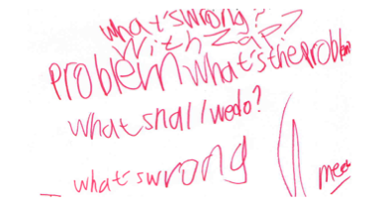
Dakota’s activity plan includes the words from the Traffic Light cards.

