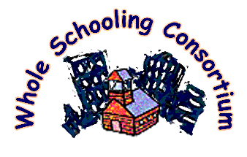
Network for

Inclusive Schooling

Creating positive change towards inclusive education for All.

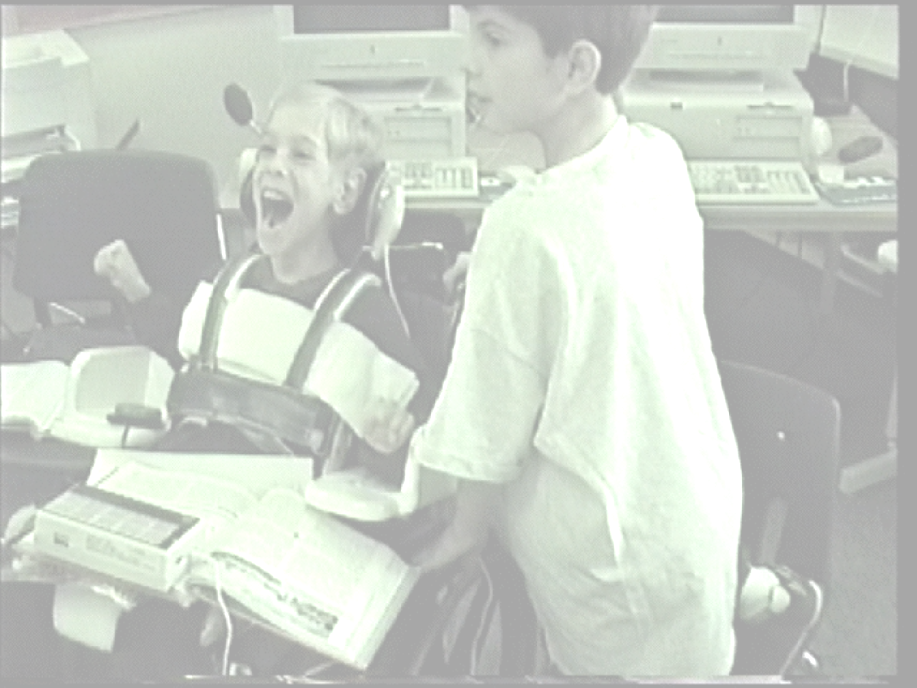

MISSION The Michigan Network for Inclusive Schooling was formed in February of 2001 by ten schools. We invite others to join us to form a truly statewide network for learning and leadership

1. Promote inclusive schooling and teaching in Michigan. By inclusive schooling we mean schools that include ALL children in heterogeneous classes learning together – students with mild to severe and multiple disabilities, gifted students, children from a wide range of racial and cultural backgrounds, and more. We commit to truly include all children together in effective learning.

2. Use the Whole Schooling frame work to guide efforts so that inclusive schooling becomes part of the culture of the school and an integral part of school improvement efforts. The Five Principles of Whole Schooling describe a culture of schooling, a framework for organizing school improvement efforts, that puts inclusive schooling and teaching at the center of all school improvement efforts.

3. Learn together – link schools, teachers, principals, parents, and others. We all have a long distance to go to have truly inclusive schools. To complete that journey, we need support and partnerships with one another. We commit to learning together to develop truly inclusive schools.

The SIX PRINCIPLES of Whole Schooling: A School Renewal Model that puts inclusive education at the center.
- Empowering citizens for democracy.
- Including all in learning together.
- Authentic, multi-level teaching.
- Building community
- Supporting learning.
- Partner with parents and community.

FOR MORE INFORMATION

www.wholeschooling.net

Network for

Inclusive Schooling

Creating positive change towards inclusive education for All.

MEMBERSHIP
APPLICATION

- School membership
- Individual membership
- Student membership

Name: _____________________________ Position: _________________________________

School (if applicable): __________________________________________________________

Address: _____________________________________________________________________

_____________________________________________________________________________

Phone: _______________________________________________________________________

Email: _______________________________________________________________________

Other interested and involved staff in the school:
The FIVE PRINCIPLES of Whole Schooling: A School Renewal Model that puts inclusive education at the center.

- Empowering citizens for democracy.
- Including all in learning together.
- Authentic, multi-level teaching.
- Building community & supporting learning.
- Partner with parents and community.

Name: _______________________________ Email: _________________________________

Name: _______________________________ Email: _________________________________

Name: _______________________________ Email: _________________________________

Name: _______________________________ Email: _________________________________

Please state your key hopes and interests in joining this network:

