
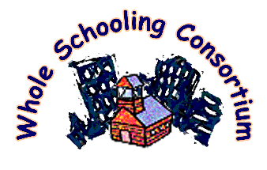

www.wholeschooling.net
WHOLE SCHOOLING
Changing the World One School at a Time!

Portland, Oregon

May 12 -13, 2006

CONFERENCE HIGHLIGHTS

The conference will be an intense, interactive 2 day learning experience combining presentations, group dialogue, keynote speakers with art, music, and poetry. Activities will be organized around the SIX PRINCIPLES OF WHOLE SCHOOLING, a framework aimed at creating effective schools for all students learning together. (See www.wholeschooling.net):

- Empowering citizens for democracy.
- Including ALL in learning together.
- Providing authentic, multi-level instruction.
- Building community.
- Supporting learning.
- Partnering with parents and the community.

Presenters will include practicing teachers, researchers, parents, advocates, and students.

Come join us in an engaging, interactive conference of best practices for all students!!

The Annual Whole Schooling Conference this year is being co-sponsored with the Parkrose School District in Portland, a district working to implement the Six Principles of Whole Schooling including movement to become a fully inclusive district. The conference will include opportunities for site visits to exemplary classrooms in Parkrose schools. The conference itself will occur in Parkrose High School, a new state-of-the-art facility designed as a community resource.

For more information go to www.wholeschooling.net and click on seminars & conferences.

Co-sponsor Partners

