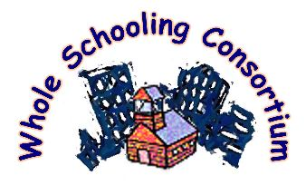

WHOLE SCHOOLING
Strengths and Needs of Our School

_______________________________ _____________________________ ________
School Name Your Name & Position (Optional) Date

DIRECTIONS Identify specific activities, programs, work we do in our school or your class related to each principle in the left column. In the right column, indicate what you think is needed to improve the school and your class under each principle.

1. EMPOWER CITIZENS IN A DEMOCRACY: Educators work to build a culture of democracy in the school among staff, in classrooms and the school community with students, parents, and community members.
My Class
Positive strategies being used Needed improvements

The School

2. INCLUDE ALL. All children learn together across differences of culture; ethnicity; language; academic, emotional, and sensory-physical abilities; gender & age.

Positive strategies being used Needed improvements
My Class

The School

3. MULTI-LEVEL, AUTHENTIC INSTRUCTION FOR LEARNERS OF DIVERSE ABILITIES. Teachers design instruction for diverse learners at multiple levels, challenge each child at his or her own level, provide scaffolds and supports and engage them in active learning in meaningful, real-world activities. Teachers develop accommodations and adaptations for learners as these are needed.

Positive strategies being used Needed improvements
My Class
The School

4. BUILD COMMUNITY & SUPPORT LEARNING. All work together to build community and mutual support within the classroom and school. The school uses specialized school and community resources (special education, title I, gifted education) to support learning and heterogeous grouping of students. Teachers and staff work proactively to understand, support, and meet the needs of students with behavioral challenges.

Positive strategies being used Needed improvements
My Class
The School

5. PARTNER WITH FAMILIES AND THE COMMUNITY. Educators build genuine collaboration for learning with families, community members, and resource organizations. They seek to engage the school and students in strengthening and improving the community.

Positive strategies being used Needed improvements
My Class
The School

OTHER IDEAS OR COMMENTS?

PLEASE RETURN THIS FORM TO _______________________ BY _______________

